1. Setup Billing Alarm

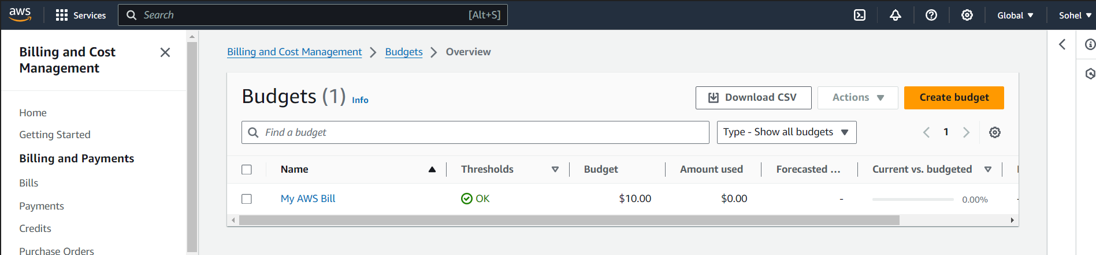

1. Create linx EC2 instance LinuxVM-001

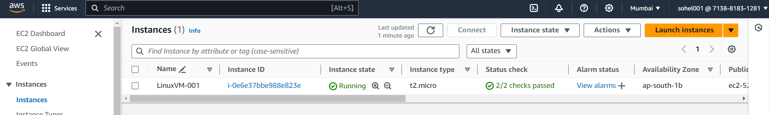

1. Setup MFA for root user

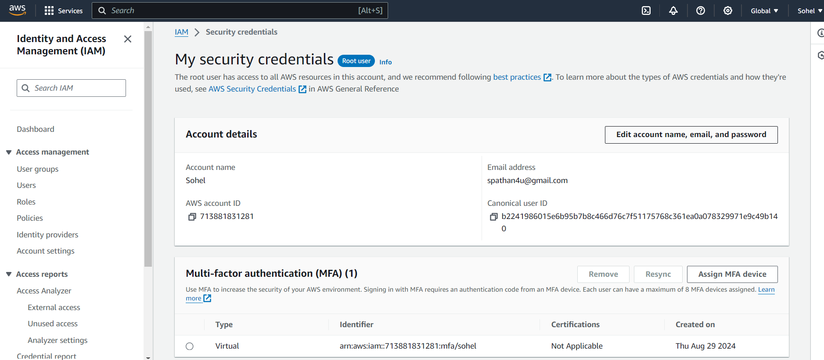

1. Create User, Group Role using GUI

User:

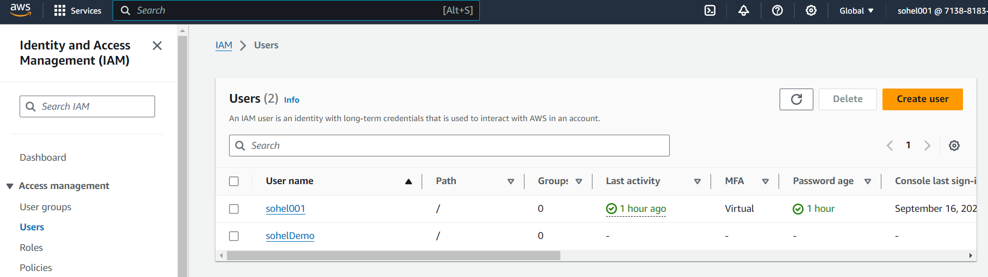

Group

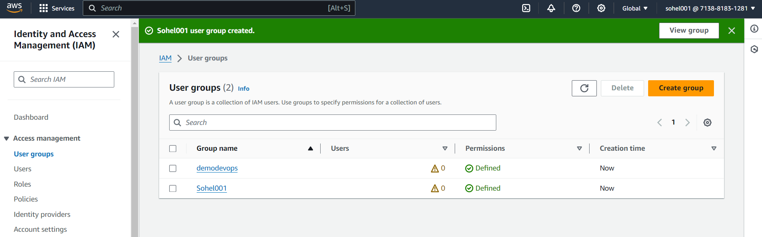

Role

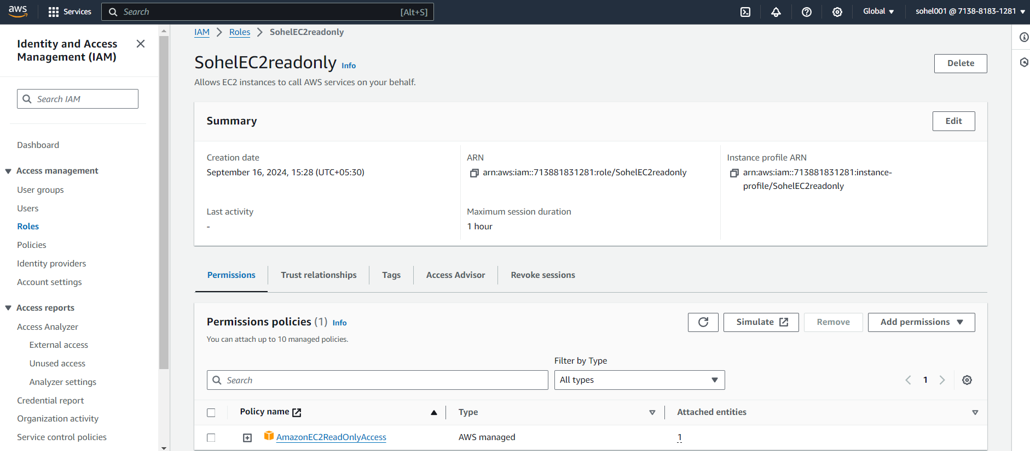

1. Create Role Group using CLI

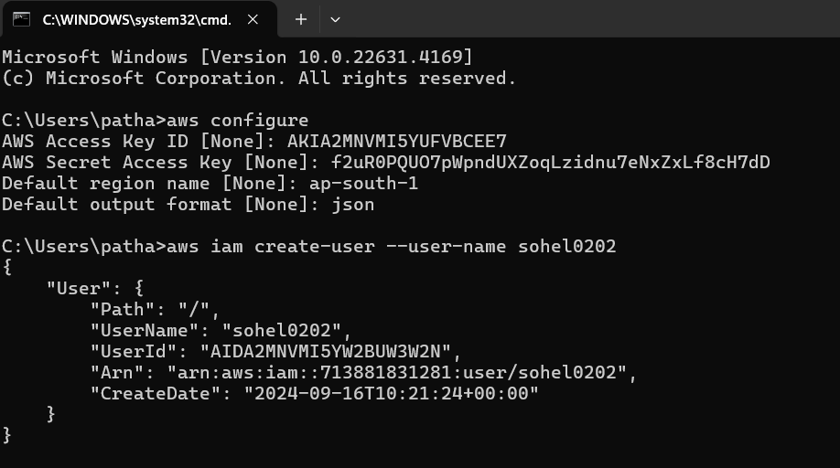

Group

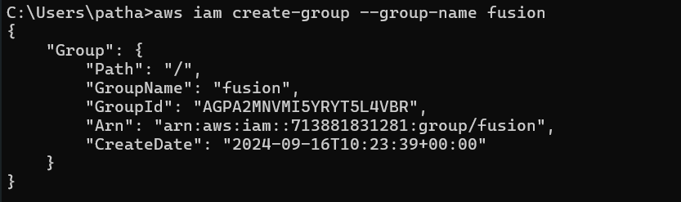

GUI:

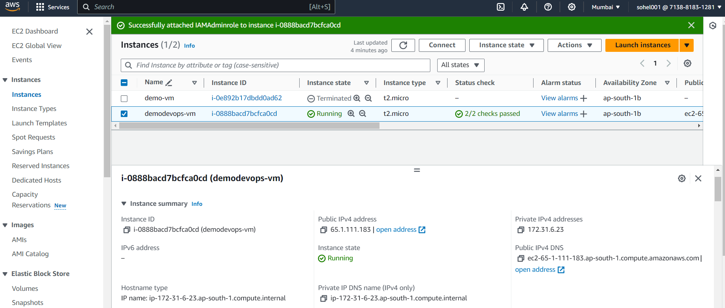

7 . Attach role and secret access key to the instance

Attach role to the instance

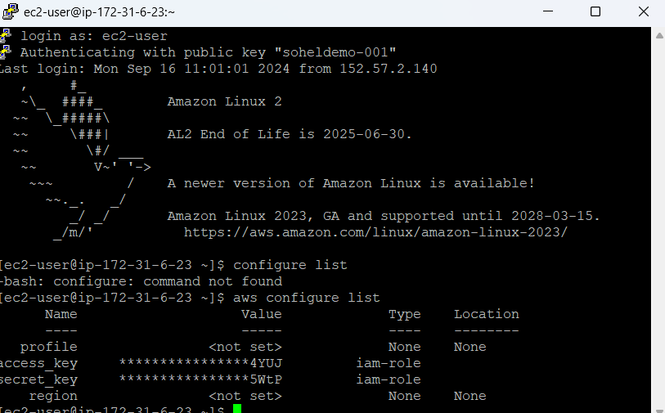

Attach secret key and acess key to the instsnce

